**PROJECT REPORT**

**IOT BASED SMART CROP PROTECTION SYSTEM FOR AGRICULTURE**

**TEAM ID: PNT2022TMID07580**

| **ROLL NUMBER** | **NAME** |
| --- | --- |
| 721719106063 | N.SOWNTHARYA |
| 721719106066 | V.SWATHI |
| 721719106067 | R.VAISHNAVI |
| 721719106068 | S.VARSHINI |

**CONTENT**

1. **INTRODUCTION**

2. **LITERATURE SURVEY**

**3. IDEATION & PROPOSED SOLUTION**

3.1 Empathy Map Canvas

3.2 Ideation & Brainstorming

3.3 Proposed Solution

3.4 Problem Solution fit

4. **REQUIREMENT ANALYSIS**

4.1 Functional requirement

4.2 Non-Functional requirement

5. **PROJECT DESIGN**

5.1 Data Flow Diagrams

5.2 Solution & Technical Architecture

5.3 User Stories

6. **PROJECT PLANNING & SCHEDULING**

6.1 Sprint Planning & Estimation

6.2 Sprint Delivery Schedule

7. **CODING & SOLUTIONING**

7.1 Feature 1

7.2 Feature 2

7.3 Feature 3

8. RESULTS

8.1 Performance Metrics

9. **ADVANTAGES & DISADVANTAGES**

10. **CONCLUSION**

11. **FUTURE SCOPE**

12. **APPENDIX**

Source Code

GitHub & Project Demo Link

**ABSTRACT**

India is a nation dependent upon agriculture. Improving the efficiency and quality of

agro-based goods therefore is very critical. This project focuses on detecting wild animals along

the farm's border and also to protect farm from fire.Here we use IR sensors to detect wild

animals,some speakers to deliver some scary sounds so animals can be afraid to get into the

field and smoke Sensor to detect fire, and microcontrollers to collect sensor data. The

microcontroller analyses the data and, based on that data, sends the signals to the speakers

that it generates the sound to stop the animals from reaching the field and also sends the safety

instructions to the cell phones of the nearest residents and farmers.IOT Based Smart Crop-Protection for Agriculture monitoring is a system describes how to monitor crop field. It is developed by using sensors and according to the decision from a server based on sensed data, the irrigation and monitoring system is enhanced. Through wireless transmission the sensed data is forwarded to web server database. If the irrigation is automated, then the moisture and temperature fields are decreased below the potential range. The user can monitor and control the system remotely with the help of application which provides a web interface to user. By smart Agriculture monitoring system and one of the oldest ways in agriculture is the manual method of checking the parameters. In this method farmers by themselves verify all the parameter and calculate the reading. It aims at making agriculture smart using automation and IoT. The cloud computing devices are used at the end of the system that can create a whole computing system from sensors to tools that observe data from agriculture field. It proposes a novel methodology for smart farming by including a smart sensing system and smart irrigator system through wireless communication technology. This system is cheap at cost for installation. Here one can access and control the agriculture system in laptop, cell phone or a computer.

**CHAPTER 1**

**INTRODUCTION**

Major challenge in Agriculture is to cultivate produce in the farm and deliver it to the end

consumers with the best possible price and best possible quality. Currently all over the world, it

is found that around 50% for the farm produce never reach the end consumer due to wastage

and suboptimal prices. IIoT (Industrial Internet of Things) tendencies are often utilized in smart

farming to boost the standard of agriculture.Wild animals regularly ruin eminence of crops.The

low productiveness is mainly due to the reasons, the crop ruined by means of untamed animals

and yield ruined by way of nature object. Cultivators are experiencing numerous challenges for

attaining more production due to unexpected encounters of animals, slight sorts of species,

beetles, some hazardous snakes and weather circumstances. Within the existing system,

electrical protection is used to give up untamed animal assaults on vegetation which leads to

the death of animals.Electrical fences are very meaningful to be certain that they're allowed to

be used in the precise area, and for defense towards endangered animal species.

Hence Smart farming can be implemented in these situations. Smart farming is a strategic

approach that focuses on providing the farming industry with the infrastructure to use

sophisticated technologies for tracking, monitoring, automating, and analyzing activities, such as

big data, the cloud, and the internet of things (IoT). Smart farming, often known as precision

agriculture, is software-managed and sensor-monitored.

**CHAPTER - 2**

**LITERATURE SURVEY**

Farmers describe the protection of crop fields as a major content and a complex

problem.But there will be major crop loss due to animal intrusion in the agricultural lands. Wild

animals are vulnerable to crops. And tracking the local presence of animals is very important.

Then the intervention of various devices to repel the dangerous animals will follow.Over the

years, the animals from the protected area [PAs] constantly invade the crop field and the

protection of this crop field has become a major concern.The method of protecting farms from

wild animals by ubiquitous wired network devices that are applied to farming along with

conventional methods to increase the efficiency of protection. The methods that are currently

being used are unsuccessful, so they present a realistic method to scare them off, by

developing a device that studies the animal's behaviour, senses the animal and produces thespecific sound that irritates the animal and also warns the designated individual by sending a

message.Thus IoT will be more helpful in protecting farm in an effective way.

**REFERENCE**:

[1] Rajesh Mallela, Pidugu Nagendra, Kadiyala Ramana, Internet of Things –Future

Internet Technologies, Elements and Applications, International Journal of Research and

Analytical Reviews, Volume.5, Issue 4, Page No pp.960-967, October 2018.

[2] Bindu D et al, International Journal of Engineering, Basic sciences, Management &

Social studies, Volume 1, Issue 1, May 2017.

[3] Archana Sahai- Security issues threats in IOT infrastructure international journal of

advanced engineering, management and science. International Journal of Advanced

Engineering, Management and Science (IJAEMS) Vol4, Issue5 ,May 2018.

[4] Abhinav & Deshpande, “Design and implementation of an intelligent security system

for farm protection from wild animals”, ISSN (Online): 2456-0448 International Journal Of

InnovativeResearch In Management, Engineering And Technology Vol. 3, Issue 2, February

2019.

**Chapter-3**

**IDEATION & PROPOSED SOLUTION**

**3.1Empathy Map Canvas:**

An empathy map is a simple, easy-to-digest visual that captures knowledge about a user’s behaviours and attitudes. It is a useful tool to helps teams better understand their users. Creating an effective solution requires understanding the true problem and the person who is experiencing it. The exercise of creating the map helps participants consider things from the user’s perspective along with his or her goals and challenges.

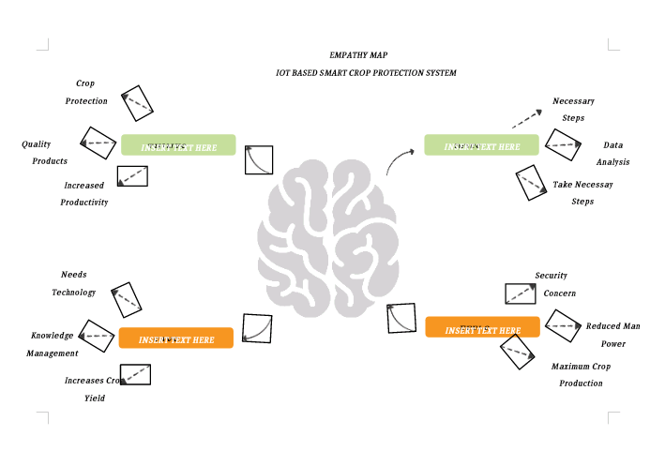

**3.2Ideation & Brainstorming:**

Brainstorming provides a free and open environment that encourages everyone within a team to participate in the creative thinking process that leads to problem solving. Prioritizing volume over value, out-of-the-box ideas are welcome and built upon, and all participants are encouraged to collaborate, helping each other develop a rich amount of creative solutions. Use this template in your own brainstorming sessions so your team can unleash their imagination and start shaping concepts even if you're not sitting in the same room.

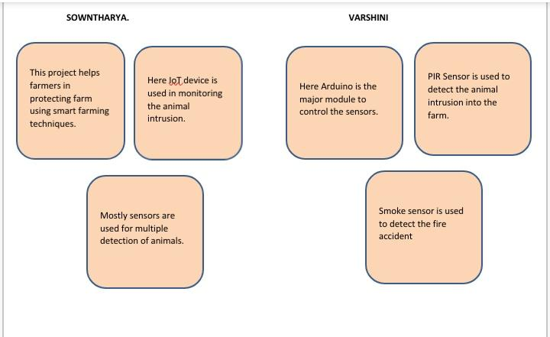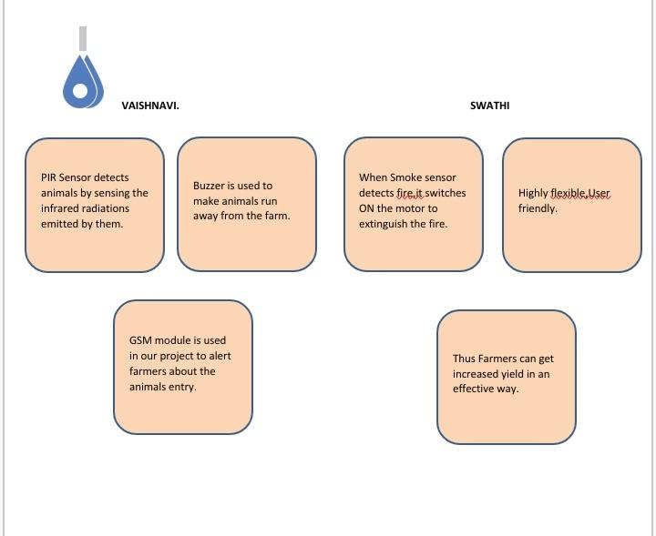

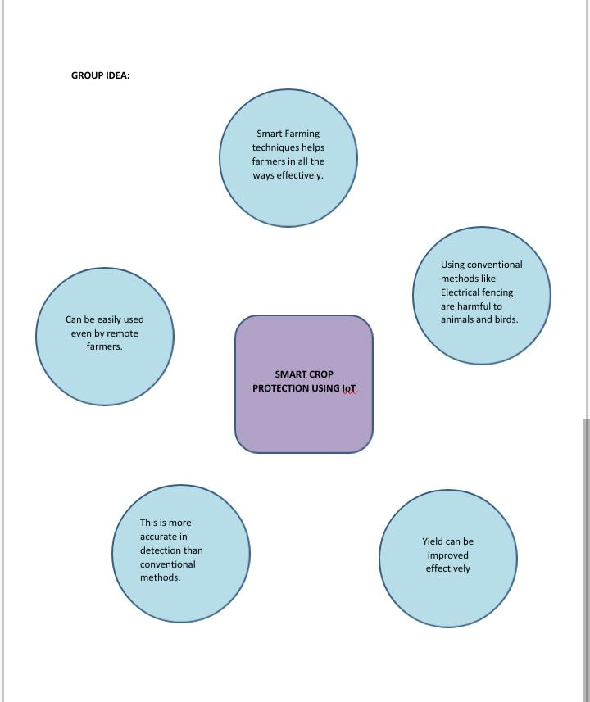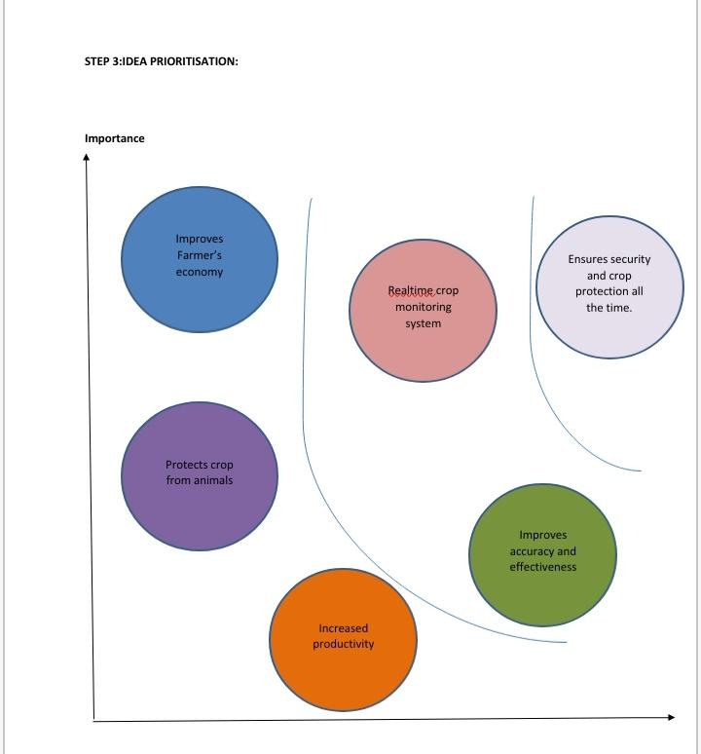

**3.3Proposed Solution:**

